Software Requirements

- Arduino IDE
- Docker
- Hyper V Enabled
- Visual Studio Code

SSL Certificates Setup

- Install openssl on windows
- Generate CA, Client and Server certificates for the ip assigned to the system
- We have a script that will generate all the three certificates using bash
- These certificated will be used by mosquito, arduino and node-js server

Initializing Required Dockers
- Mosquitto Secure Container
  - Write a docker compose file that pulls the mosquito latest image and installs
  - Create a certs folder and copy all the created certificates into that folder
  - Mount the local certs folder with container volume using the volume argument in docker compose file
  - version: '3.5'

  - services:
  - mosquitto:
  - container_name: mosquitto_container
  - image: eclipse-mosquitto:1.6.10
  - volumes:
  - - ./config:/mosquitto/config/
  - ports:
  - - '8883:8883'
  - networks:
  - - default
  - restart: unless-stopped

  - networks:
  - default:
  - Start the docker compose file using command docker-compose up –d
- Grafana Container
  - Pull and install the latest grafana image
  - docker run -d -p 3000:3000 --name grafana grafana/grafana-enterprise:8.2.0

- Prometheus Container
  - Created a Prometheus.yml file in C://Users/PC/tmp/
  - Add initial and mqqt exporter configuration into the file
  - Set the mqqt exporter ip to local machine ip
  - Mount the Prometheus.yml file directory to docker container volume
  - docker service create --replicas 1 --name my-prometheus --mount type=bind,source=/tmp/prometheus.yml,destination=/etc/prometheus/prometheus.yml --publish published=9090,target=9090,protocol=tcp prom/prometheus

- Mqtt Exporter Container
  - Pull and install the mqtt container
  - Pass the host ip address as of local machine and set the port to 1883
  - docker run --name mqttde_container -d -e MQTTHOST=192.168.43.69 -e MQTTPORT=1883 -e EXPOTIMEOUT=60 -p 9021:9021 iam21h/mqtt-data-exporter:0.0.1
  - Check mqtt exporter status
  - 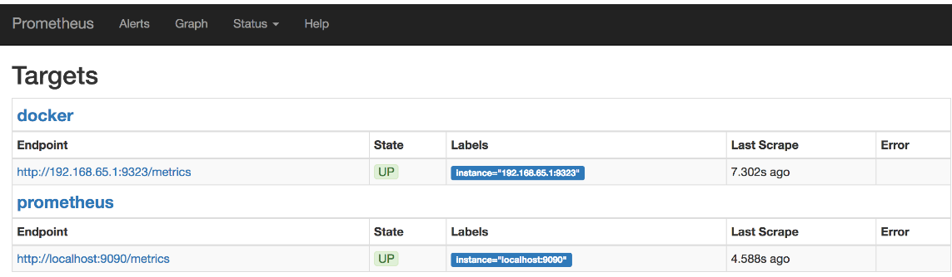

Secure Esp32 and MQTT Connectivity

- Change the WifiSecureClient library of esp32 to an older commit which is stable and allows the ssl connection to mqtt
- Change the file in Arduino15/hardware/libraries/esp32/1.0.0/
- Upload three certificates in the Arduino code i.e CA CERT, Cient.Key and Client Cert
- Change port from 1883 to 8883
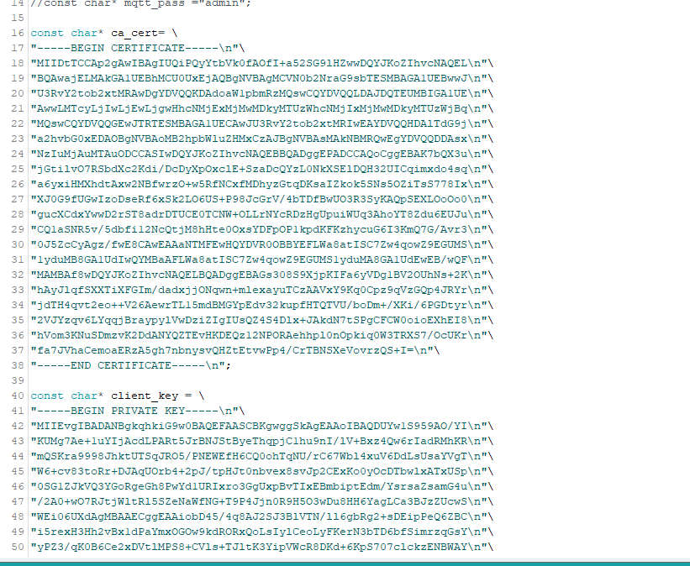

Connect Prometheus with Grafana
- Add the Prometheus plugin in grafana
- Add local system ip in the Prometheus plugin
- Save and test the connection
- 

Create Dashboard on Grafana
- Clink on add new panel after clicking on dashboard
- Add the panel title
- Select data source for the panel and apply changes

